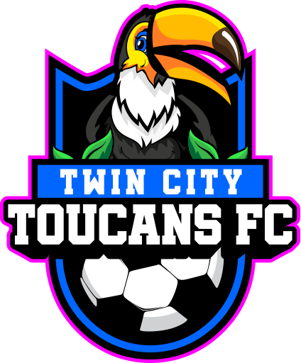

Twin City Toucans Sponsorship Form
Thank you for supporting local soccer! We invite you to become a sponsor of Twin City Toucans, a dedicated and growing pre-professional soccer team proudly representing Bryan/College Station. Your sponsorship helps cover essential costs such as uniforms, travel, training facilities, hosting and feeding players, and league fees - while gaining exposure for your business in our community. Jersey sponsorships have expanded reach due to away games being played across south and central Texas, as well as livestreams across the world.
Sponsorship Levels
Platinum Sponsor - $5,000 - available for summer 2026
- Logo on front of team jerseys
- Featured logo on team website & social media
- Banner placement at home games
- Public PA mentions at matches
- Complimentary team jersey
Gold Sponsor - $2,500 - available for summer 2026
- Logo on back of team jerseys
- Logo on team website & social media
- PA mentions at matches
- Complimentary team t-shirt
Silver Sponsor - $1000
- Logo on team banner at games
- Social media shoutouts
- Listing on team website
Bronze Sponsor - $500
- Business name listed on website
- Thank-you post on social media
Game Night Sponsor - $4,000
- Banner placement at midfield for that specific game
- Public PA mentions during the game
- Recognition at halftime events
- Logo on team website and social media posts
- Unlimited game tickets for your company for that game

Twin City Toucans Sponsorship Form
Sponsor Information
Business/Organization Name:
Contact Person:
Phone Number:
Email:
Mailing Address:
Website or Social Media Handle (if applicable):
Preferred Sponsorship Level
[ ] Platinum ($5,000) - please contact us for interest in this level
[ ] Gold ($2,500) - please contact us for interest in this level
[ ] Silver ($1,000)
[ ] Bronze ($500)
[ ] Game Night ($4,000)
[ ] Custom Amount: $_____________
Upload Logo or Artwork
Please email your logo in high resolution (PNG, EPS, or PDF) to: rick@toucansfc.com

Payment Information
Please make checks payable to: Seabolt Sports Group, LLC
Mail to:
Twin City Toucans
4446 Tuscany Trace
College Station, Tx 77845

Or pay online via: https://buy.stripe.com/8x27sL55C1nF0uTak44wM01

Contact Us
Twin City Toucans Sponsorship Form
For questions or more information, contact:
Rick Seabolt
Phone: 979-255-8545
Email: rick@toucansfc.com
Website: www.toucansfc.com
Twin City Toucans and our players thank you for your support and belief in local talent!
*This sponsorship is not tax-deductible unless we are a registered 501(c)(3). Please consult your tax advisor.*

